How to install 3 master node 2 worker node assisted openshift cluster

* Open [Log In | Red Hat IDP](https://sso.redhat.com/auth/realms/redhat-external/protocol/openid-connect/auth?client_id=cloud-services&redirect_uri=https%3A%2F%2Fconsole.redhat.com%2F&response_type=code&scope=openid&nonce=e3c5bbbb-e7ca-4c50-8639-fcf9114d14e5&state=8f0e5febf999469cb7bf90f7eb8fee80&response_mode=fragment)
* Login. Goto Openshift

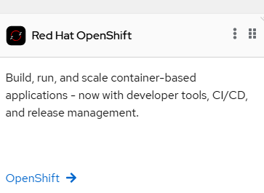

* Goto cluster list and click on required cluster.

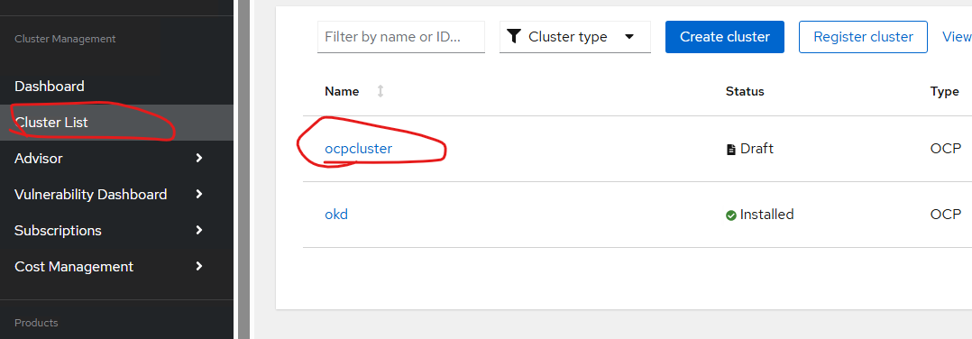

* Fill up the cluster details.

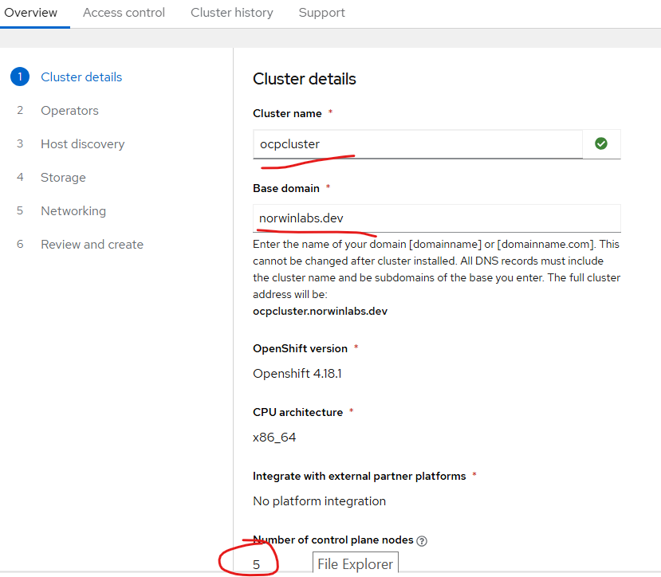

* Now goto host discovery option.
* Click on add host.
* Generate ssh-key on your local machine with command

*ssh-keygen*

* Copy the ssh key generated and paste it on SSH public key in redhat-console URL

Use minimal ISO image option in below snap.

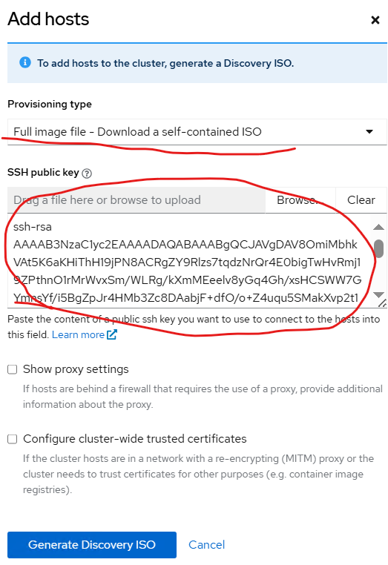

* Generate ISO key
* Get ISO URL and paste it in openshift-3control-2worker.sh script under ISO URL
* Download the ISO image and put path in ISO path field
* Open git bash in your desktop and run the script on it ( download git bash if its not installed)
* You may face issue on boot. Just reload the ISO image on CD drive and shutdown/power on VM.
* If there is issue in VM accessing the registries just delete the NAT adapter and remake them.